Caithness Cycling Club
Invite you to their
Racing Weekend
2nd & 3rd May 2015

Sponsored By

Dounreay Communities Fund

Event 1: 25 Mile TT
Start: | Saturday 2nd May 2015, 3pm, on A9 50 yards east of "Welcome to Thurso" sign on south side of Thurso
Course: | Continue on A9/A882 through Watten to turn 1 mile east of Watten village.
Finish: | 400 yards short of start.
Event 2: Loch Calder Hilly Time Trial, 24 Miles
NOSCA SPECIAL SERIES EVENT
Note: - The circuit is Anticlockwise.
Start: | Sunday 3rd May 2015, 10am, by Thurso Technical College
Course: | Start at lamppost opposite the Electrical Substation at Thurso Technical College. Proceed toward Reay, taking the left turn at Bridge of Westfield (4miles). Proceed to Achavarn (4 miles) turning left and following the road to Glengolly. At Glengolly turn left and continue to the junction (¼ mile) turning left to repeat the circuit a second time.
Finish: | On the second lap the finish is at the first house as you enter Glengolly ¼ of a mile from the junction.
HQ for all events for signing on, numbers, etc. and for times, prizes and refreshments after the races, is the Clubrooms,
7 Gerry Square, KW14 7GB, 200yds from town centre, off Olrig Street, on the road west.
“Sign On” in the clubrooms from 1 hour before the event start time
(Additional Prizes for competitors in both events)
For Start Sheet, Results, etc, visit –
http://CaithnessCC.co.uk
Please DO NOT PARK in Gerry Square.

Event 1: 25 mile Time Trial
Saturday 2nd May, 3pm, Start on A9 50 yards east of "Welcome to Thurso" sign on south side of Thurso
Prizes
First |  | £25
Second |  | £20
Third |  | £15
First Handicap |  | £15
1st Vet on Age Standard |  | £15
1stJun/Yth/Ldy on Handicap |  | £15
Caithness CC 25 mTT
02 May 2015
NS7
COMPETITOR START LIST
No. | Rider |  | Team |  |  |  | Cat |  | Start Time |  | Finish Time |  |  | Race Time |  |  | H'Cap Allow. |  |  |  |  | Nett Time |  |  | Vet Std |  |  |  | Plus
1 |  |  |  |  |  |  |  |  | 15:01
2 |  |  |  |  |  |  |  |  | 15:02
3 |  |  |  |  |  |  |  |  | 15:03
4 | Lorna Stanger |  | Caithness CC |  |  |  | FV |  | 15:04 |  |  |  |  |  |  |  | 0:14:44 |  |  |  |  |  |  |  | 1:12:36
5 | Gary Angus |  | Caithness CC |  |  |  | V |  | 15:05 |  |  |  |  |  |  |  |  |  |  |  |  |  |  |  | 1:09:05
6 | Steven Liddle |  | Ben Wyvis Cycle |  |  |  | V |  | 15:06 |  |  |  |  |  |  |  | 0:08:25 |  |  |  |  |  |  |  | 1:06:00
7 | Duncan Gillies |  | Elgin CC |  |  |  | V |  | 15:07 |  |  |  |  |  |  |  |  |  |  |  |  |  |  |  | 1:10:57
8 | Alan Cook |  | Cromarty Firth CC |  |  |  | V |  | 15:08 |  |  |  |  |  |  |  | 0:16:27 |  |  |  |  |  |  |  | 1:09:49
9 | Cameron Earnshaw |  | Caithness CC |  |  |  | YM |  | 15:09 |  |  |  |  |  |  |  | 0:24:48
10 | Christopher Goddard |  | Moray Firth CC |  |  |  | V |  | 15:10 |  |  |  |  |  |  |  | 0:08:35 |  |  |  |  |  |  |  | 1:06:51
11 | Keith MacRae |  | East Sutherland Wheelers |  |  |  | V |  | 15:11 |  |  |  |  |  |  |  | 0:17:59 |  |  |  |  |  |  |  | 1:09:05
12 | Scott Macdonald |  | Cromarty Firth CC |  |  |  | V |  | 15:12 |  |  |  |  |  |  |  | 0:15:21 |  |  |  |  |  |  |  | 1:06:51
13 | Peter Ettles |  | Sandy Wallace Cycles |  |  |  | V |  | 15:13 |  |  |  |  |  |  |  | 0:03:06 |  |  |  |  |  |  |  | 1:08:14
14 | Alun Arnold |  | Wick Wheelers |  |  |  | V |  | 15:14 |  |  |  |  |  |  |  | 0:11:59 |  |  |  |  |  |  |  | 1:06:26
15 | Gregor Grant |  | Moray Firth CC |  |  |  | V |  | 15:15 |  |  |  |  |  |  |  | 0:08:14 |  |  |  |  |  |  |  | 1:09:34
16 | John Cummings |  | Deeside Thistle |  |  |  | V |  | 15:16 |  |  |  |  |  |  |  | 0:11:04 |  |  |  |  |  |  |  | 1:08:52
17 | Andrew MacLeod |  | Caithness CC |  |  |  | S |  | 15:17 |  |  |  |  |  |  |  | 0:08:49
18 | David Stuart |  | Cromarty Firth CC |  |  |  | V |  | 15:18 |  |  |  |  |  |  |  | 0:10:17 |  |  |  |  |  |  |  | 1:06:51
19 | Alasdair Washington |  | Caithness CC |  |  |  | V |  | 15:19 |  |  |  |  |  |  |  | 0:13:12 |  |  |  |  |  |  |  | 1:18:26
20 | Tony Hay |  | Highland Bikes Racing Team |  |  |  | V |  | 15:20 |  |  |  |  |  |  |  | 0:05:29 |  |  |  |  |  |  |  | 1:06:13
21 | Alan Cockburn |  | East Sutherland Wheelers |  |  |  | V |  | 15:21 |  |  |  |  |  |  |  | 0:20:54 |  |  |  |  |  |  |  | 1:08:52
22 | Allan Sutherland |  | Caithness CC |  |  |  | S |  | 15:22 |  |  |  |  |  |  |  | 0:08:25
23 | Phil Cartwright |  | Caithness CC |  |  |  | V |  | 15:23 |  |  |  |  |  |  |  | 0:17:09 |  |  |  |  |  |  |  | 1:09:05
24 | David Morrill |  | Caithness CC |  |  |  | V |  | 15:24 |  |  |  |  |  |  |  |  |  |  |  |  |  |  |  | 1:08:14
25 | Andy Cowie |  | Highland Bikes Racing Team |  |  |  | V |  | 15:25 |  |  |  |  |  |  |  | 0:04:11 |  |  |  |  |  |  |  | 1:07:38
26 |  |  |  |  |  |  |  |  | 15:26
27 |  |  |  |  |  |  |  |  | 15:27
28 |  |  |  |  |  |  |  |  | 15:28

Event 2: Loch Calder Hilly Time Trial, 24 Miles
(NOSCA SPECIAL SERIES – Event 1 of 7)
Sunday 3rd May, 10am, Start by Thurso Technical College
Prizes
First | £25
Second | £20
Third | £15
First Handicap | £15
1st Vet on Age Standard | £15
1stJun/Yth/Ldy on Handicap | £15

Loch Calder Hilly
03 May 2015
Loch Calder Hilly
COMPETITOR START LIST
No. | Rider | Team |  | Cat | Start Time | Finish Time | Race Time | H'Cap Allow. | Nett Time | Vet Std |  | Plus
1 |  |  |  |  | 10:01
2 |  |  |  |  | 10:02
3 |  |  |  |  | 10:03
4 |  |  |  |  | 10:04
5 | Lorna Stanger | Caithness CC |  | FV | 10:05 |  |  | 0:14:44 |  | 1:12:36
6 | Cameron Earnshaw | Caithness CC |  | YM | 10:06 |  |  | 0:24:48
7 | Duncan Gillies | Elgin CC |  | V | 10:07 |  |  |  |  | 1:10:57
8 | Alan Cook | Cromarty Firth CC |  | V | 10:08 |  |  | 0:16:27 |  | 1:09:49
9 | Phil Cartwright | Caithness CC |  | V | 10:09 |  |  | 0:17:09 |  | 1:09:05
10 | Michael Gordon | Moray Firth CC |  | V | 10:10 |  |  | 0:08:48 |  | 1:09:34
11 | Alasdair Washington | Caithness CC |  | V | 10:11 |  |  | 0:13:12 |  | 1:18:26
12 | Mark Dryburgh | Ross-Shire Roads |  | V | 10:12 |  |  | 0:09:34 |  | 1:06:39
13 | Peter Ettles | Sandy Wallace Cycles |  | V | 10:13 |  |  | 0:03:06 |  | 1:08:14
14 | Allan Sutherland | Caithness CC |  | S | 10:14 |  |  | 0:08:25
15 |  |  |  |  | 10:15
16 |  |  |  |  | 10:16
17 |  |  |  |  | 10:17
18 |  |  |  |  | 10:18
19 |  |  |  |  | 10:19
20 |  |  |  |  | 10:20
21 |  |  |  |  | 10:21
22 |  |  |  |  | 10:22
23 |  |  |  |  | 10:23
24 |  |  |  |  | 10:24
25 |  |  |  |  | 10:25
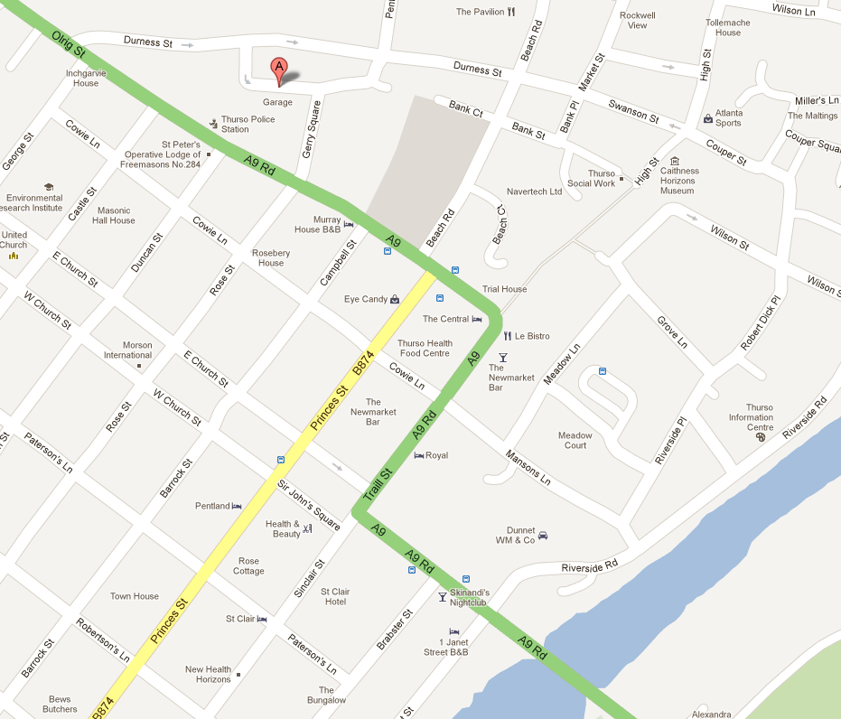
Caithness Cycling Club
7 Gerry Square
Thurso
Caithness
Scotland
KW14 7GB
Route Map – 25mTT & Loch Calder Hilly


