 | Risk Assessment
Course/Road(s) Assessed: Thurso/Wick Interclub | Course: CCC/WW Interclub – Thurso to Wick
Date of Assessment/Review: 12/02/2019 | Name of Assessor: Committee

Course Description: Caithness Cycling Club / Wick Wheels (Thurso to Wick) Interclub Course.

Start on A9 at the farm entrance, 50 yards east of "Welcome to Thurso" sign on south side of Thurso, continue on A9/A882 through Watten to finish (19.031 miles) at the lamppost just before Langley Ln.

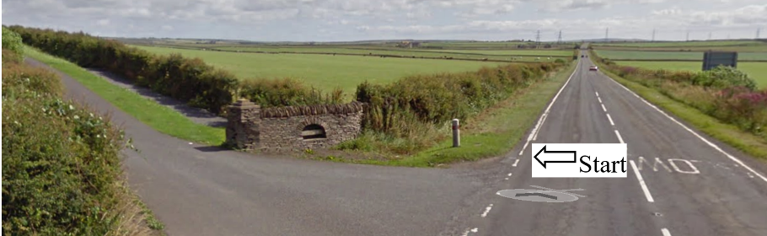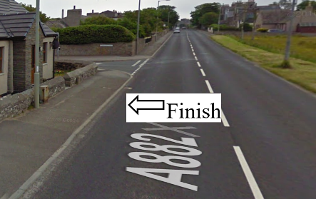

Traffic Flows: The course is from Thurso to Wick (one way)

Course/Event History: This course has been used regularly for over 15 years.

Key Identified Risks

Distance | Location | Identified Significant Risk/Hazards | Level of Risk  Low/Med/High | Measures to reduce Risk  (if applicable)
Miles 0.0 | Start  Located at farm entrance road just outside Thurso on the A9. | Traffic | Med | Signage to warn traffic  Start coned off  Timekeeper  Marshall to push off competitors  Marshalls to wear HiVis
Miles 2.0 | Weydale turnoff – straight on | Minor road turn off | Low | Minor road turn off (No action required)
Miles 3.5 | Sordale turnoff - straight on | Minor road turn off | Low | Minor road turn off (No action required)
Miles 4.4 | Roadside turnoff - straight on | Minor road turn off | Low | Minor road turn off (No action required)
Miles 4.5 | Roadside crossroads - straight on | Minor road turn off | Low | Crossroads from Roadside to Halkirk (No action required)
Miles 8.3 | Gillock turnoff - straight on | Minor road turn off | Low | Minor road turn off (No action required)
Miles 11.1 | Watten 30mph | No Hazard | N/A | 30 MPH speed limit
Miles 11.3 | Pedestrian Crossing | Hazard to cyclist & pedestrians | Med | Cyclists to observe Highway Code and give way to pedestrians
Miles 11.4 | Watten Crossroads - straight on | Minor road turn off | Low | Minor Crossroads in town of Watten (No action required)
Miles 11.5 | Watten end of 30mph | No Hazard | N/A | End of 30 MPH speed limit
Miles | Wick 30mph | No Hazard | N/A | 30 MPH speed limit
Miles 18.9 | Turnoff to Riverside Drive - straight on | Minor road turn off | Low | Minor road turn off (No action required)
Miles 19.031 | Finish at the lamppost just before Langley Ln.  See picture above. |  | Low | Signage to warn traffic  Marshalls to wear HiVis

NOTES:

1. The use of a vehicle for the timekeeper(s) at start and finish is where appropriate and is only identified as an example for the action to be taken
2. The small junctions or entrances to farms/ facilities (garage,.eatery, etc) that are not identified in this risk assessment have been considered, however are not considered significant to pose a risk and therefore have not been noted.

Date of original Assessment: 09/02/2019

