 | Risk Assessment
Course/Road(s) Assessed: WN10/01 | Course: CCC 10mtt A9 (BC-NS32)
Date of Assessment/Review: 12/02/2019 | Name of Assessor: Committee

Course Description: Caithness Cycling Clubs 10 mile TT course..
The course is a registered British Cycling course (NS32).

Start on A9 50 yards east of "Welcome to Thurso" sign on south side of Thurso, continue on A9/A882 for 5.071 miles. Turn 26 yards past the "Wick 15 Miles" sign. Retrace to finish 400 yards short of start.

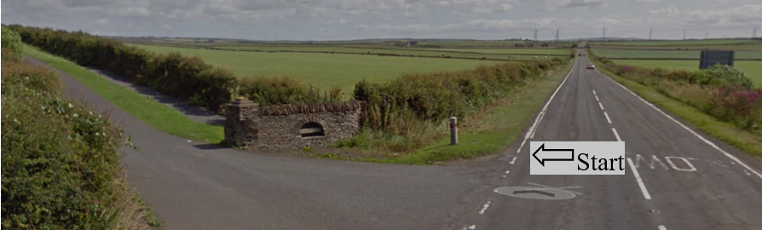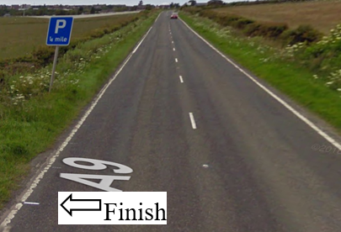

Traffic Flows: The course is an out and back course with a Dead Turn.

Course/Event History: This course has been used regularly for over 20 years.

Key Identified Risks

Distance | Location | Identified Significant Risk/Hazards | Level of Risk  Low/Med/High | Measures to reduce Risk  (if applicable)
Miles 0.0 | Start  Located at farm entrance road on the A9 just outside Thurso. | Traffic | Med | Signage to warn traffic.  Start coned off.  Timekeeper.  Marshall to push off competitors.  Marshalls to wear HiVis.
Miles 2.0 | Weydale turnoff – straight on | Minor road turn off | Low | Minor road turn off (No action required)
Miles 3.5 | Sordale turnoff - straight on | Minor road turn off | Low | Minor road turn off (No action required)
Miles 4.4 | Roadside turnoff - straight on | Minor road turn off | Low | Minor road turn off (No action required)
Miles 4.5 | Roadside crossroads - straight on | Minor road turn off | Low | Crossroads from Roadside to Halkirk (No action required)
Miles 5.1  Dead Turn | Dead Turn – go past and round turn marshall | Oncoming traffic | Med | Cyclist to give way to traffic and observe the highway code.  Signage to warn traffic approaching the course.  Marshall to warn traffic approaching the course.  Marshalls to wear HiVis.
Miles 5.15 | Georgmas turnoff - straight on | A9 Junction – cyclist has the right of way | Low | Signage to warn traffic turning onto the course
Miles 5.3 | Roadside crossroad - straight on | Minor road turn off | Low | Crossroads from Roadside to Halkirk (No action required)
Miles 10 | Finish 400 yards short of the Start |  | Low | Signage to warn traffic  Marshalls to wear HiVis

NOTES:

1. The use of a vehicle for the timekeeper(s) at start and finish is where appropriate and is only identified as an example for the action to be taken
2. The small junctions or entrances to farms/ facilities (garage,.eatery, etc) that are not identified in this risk assessment have been considered, however are not considered significant to pose a risk and therefore have not been noted.

Date of original Assessment: 23/08/2018

