 | Risk Assessment
Course/Road(s) Assessed: WN10/02 | Course: CCC 10mtt Shebster
Date of Assessment/Review: 12/02/2019 | Name of Assessor: Committee

Course Description: Caithness Cycling Clubs 10 mile TT Shebster course.

Start at the road junction opposite the Recycling Centre 1 mile outside Thurso on the B874.
Proceed for 5.19 miles to the turn at the fist gate post of the entrance to the house.
Retrace 4.81 miles to the finish at the Red Terlephone Box just past the Janetstown junction.

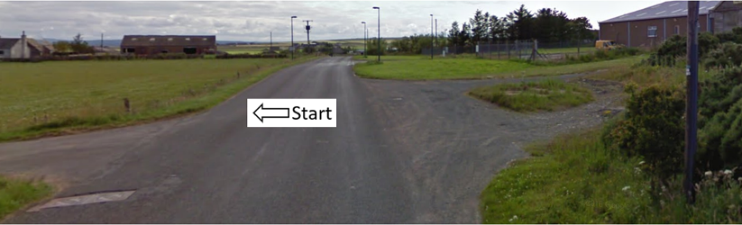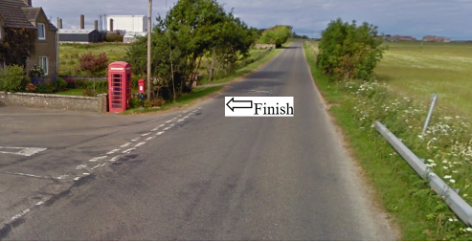

Traffic Flows: The course is Out and Back with a Dead Turn.

This course would be used as a backup if there were roadworks etc on the normal 10mTT course WN10/01

Course/Event History: This course has been used regularly for over 5 years.

Key Identified Risks

Distance | Location | Identified Significant Risk/Hazards | Level of Risk  Low/Med/High | Measures to reduce Risk  (if applicable)
Miles 0.0 | Start  Located at the road junction opposite the Recycling Centre 1 mile outside Thurso on the B874. | Traffic | Med | Signage to warn traffic.  Start coned off.  Timekeeper.  Marshall to push off competitors.  Marshalls to wear HiVis.
Miles 0.8 | Achscrabster turn off – go straight ahead | Minor road turnoff | Low | Minor road turn off – (No action required)
Miles 2.69 | Lieurary/Calder turn off – go straight ahead | Minor road turnoff | Low | Minor road turn off – (No action required)
Miles 5.19  Dead Turn | Dead Turn.  At fist gate post of entrance to house.  Turn – go past and round turn marshall. | Oncoming traffic | Med | Cyclist to give way to traffic and observe the highway code.  Signage to warn traffic approaching the course.  Marshall to warn traffic approaching the course.  Marshalls to wear HiVis.
Miles 8.26 | Lythmore turn off – go straight ahead | Minor road turnoff | Low | Minor road turn off – (No action required)
Miles 9.99 | Janetstown turn off – go straight ahead | Minor road turnoff | Low | Minor road turn off – (No action required)
Miles 10.0 | Finish - at Red Terlephone Box just past the Janetstown junction. |  | Low | Time keeper  Recorder  Signage to warn traffic  Marshalls to wear HiVis

NOTES:

1. The use of a vehicle for the timekeeper(s) at start and finish is where appropriate and is only identified as an example for the action to be taken
2. The small junctions or entrances to farms/ facilities (garage,.eatery, etc) that are not identified in this risk assessment have been considered, however are not considered significant to pose a risk and therefore have not been noted.

Date of original Assessment: 23/08/2018

