 | Risk Assessment
Course/Road(s) Assessed: WN11-01 | Course: CCC 11mile Loch Calder Hilly TT
Date of Assessment/Review: 12/02/2019 | Name of Assessor: Committee

Course Description: Caithness Cycling Clubs 11 mile Loch Calder Hilly TT course.

Start at lamppost opposite the Electrical Substation at North Highland College on the B874.
Proceed toward Reay, taking the second left (3.8m) onto the single track road at Bridge of Westfield.
Continue on to Achavarn (3.6m) (beware of the "Z" bend 1 mile after the junction) and turn left onto the B870 (single track road).
Proceed for 3.7m finishing at the lampost at the first house entering Glengolly.

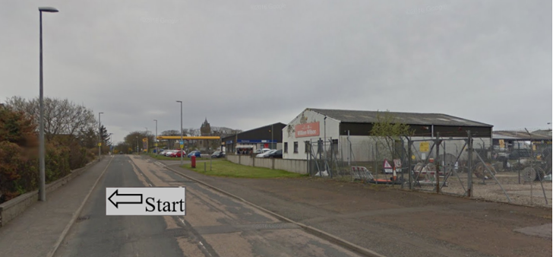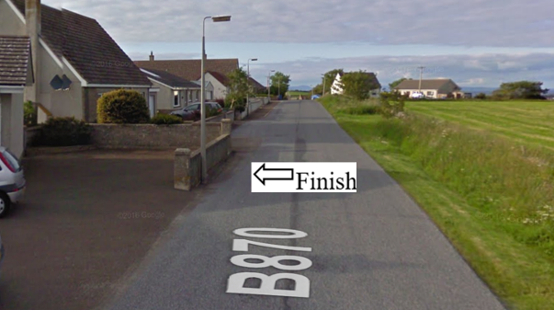

Traffic Flows: The course is a circuit

Course/Event History: This course has been used regularly for over 15 years. The circuit was changed to anti clockwise to reduce the risk of right hand turns.

Key Identified Risks

Distance | Location | Identified Significant Risk/Hazards | Level of Risk  Low/Med/High | Measures to reduce Risk  (if applicable)
Miles 0.0 | Start  Located at the lamppost opposite the substation near North Highland College. | Traffic | Med | Signage to warn traffic.  Start coned off.  Timekeeper.  Marshall to push off competitors.  Marshalls to wear HiVis.
Miles 0.2 | End of 30 mph speed limit |  | N/A | No action required
Miles 0.8 | Halkirk turn off – go straight ahead | Minor road turnoff | Low | Minor road turn off – (No action required)
Miles 3.8  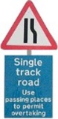 | Bridge of Westfield junction - Turn Left onto single track road | Turning left onto single track road | Low | Signage to warn traffic approaching the course.  Marshalls to warn traffic approaching the course.  Marshalls to wear HiVis.
Miles 4.3 | Z bend | Requires caution | Low | Cyclists to proceed through the Z Bend with caution noting that there might be on coming vehicles on the single track road.
Miles 7.4 | Give Way and Left turn onto B870 - Single track road | Minor Road Junction.  Traffic on road that is being joined has the right of way. | Med | Cyclist to give way to traffic and observe the highway code.  Signage to warn traffic approaching the course.  Marshalls to warn traffic approaching the course.  Marshalls to wear HiVis.
Miles 11.1 | Finish - at the lampost at the first house entering Glengolly |  | Low | Time keeper  Recorder  Signage to warn traffic  Marshalls to wear HiVis

NOTES:

1. The use of a vehicle for the timekeeper(s) at start and finish is where appropriate and is only identified as an example for the action to be taken
2. The small junctions or entrances to farms/ facilities (garage,.eatery, etc) that are not identified in this risk assessment have been considered, however are not considered significant to pose a risk and therefore have not been noted.

Date of original Assessment: 23/08/2018

