 | Risk Assessment
Course/Road(s) Assessed: WN13/01 | Course: CCC 13m Mount Pleasant Hilly
Date of Assessment/Review: 12/02/2019 | Name of Assessor: Committee

Course Description: Caithness Cycling Clubs 13m Mount Pleasant Hilly course.

Start at the left-hand side of the railings at the crossing over to Mount Pleasant School on the A836 (Thurso to Castletown).
At 0.09 mile turn left and proceed for 5.73 miles to the Castletown/Durran junction.
Turn Left and continue for 2.81 miles and turn left and proceed for 0.5 miles and turn Left at the Crossroads.
Continue for 2.36 miles and turn right continuing to the Finish at the Telegraph Pole on the right hand side of the road at 13 miles.

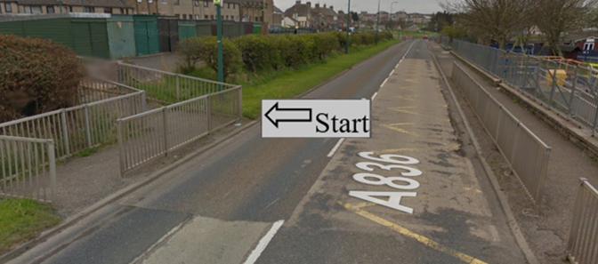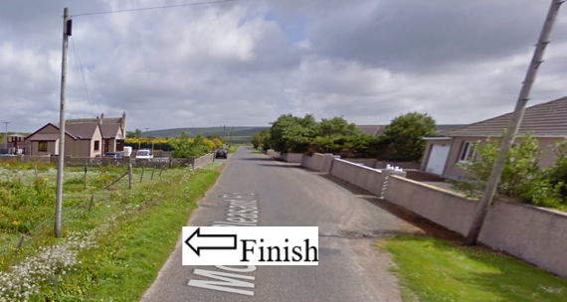

Traffic Flows: The course is a circuit.
The first 0.39 miles are in a built up area, then the rest of the course is on Single Track Roads.

Course/Event History: This course has been used regularly for over 5 years.

Key Identified Risks

Distance | Location | Identified Significant Risk/Hazards | Level of Risk  Low/Med/High | Measures to reduce Risk  (if applicable)
Miles 0.0 | Start  Located at the left-hand side of the railings at the crossing over to Mount Pleasant School | Traffic | Med | Signage to warn traffic.  Start coned off.  Timekeeper.  Marshall to push off competitors.  Marshalls to wear HiVis.
Miles 0.09 | Turn Left onto Mount Pleasant Road. | Left turn | Low | Signage to warn traffic approaching the course.  Marshalls to warn traffic approaching the course.  Marshalls to wear HiVis.
Miles:-  0.09 to 0.34  Warning | Warning:- This is a built-up area.  There are 4 crossroads followed by 4 left junctions (+1 right) as you climb the hill to the end of the 30 MPH speed limit. | Pedestrians and vehicles | Low | Cyclists to observe Highway Code and be aware of pedestrians and vehicles.
Miles 0.13  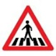 | Pedestrian Crossing | Hazard to cyclist & pedestrians | Med | Cyclists to observe Highway Code and give way to pedestrians
Miles 0.34 | End of 30 mph speed limit |  | N/A | No action required
Miles 0.34  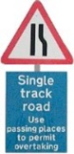 | Single Track Road to the finish – Un-named Road | From this point to the finish the course is on Single Track roads | N/A | No action required
Miles 2.72 | Castletown turn off – go straight ahead | Minor road turnoff | Low | Minor road turn off – (No action required)
Miles 3.18  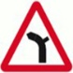 | Left Hand Bend with junction on the right  Keep left. | Minor road junction | Low | Minor road turn off – (No action required)
Miles 5.82 | Give Way and turn Left onto Castletown/Durran road. | Left turn onto minor road.  Single track road.  Traffic on road that is being joined has the right of way. | Med | Signage to warn traffic approaching the course.  Marshalls to warn traffic approaching the course.  Marshalls to wear HiVis.
Miles 7.14  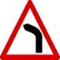 | Warning - Left Hand bend. | Sharp Left Hand bend. | Low | No action required
Miles 7.95  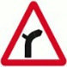 | Right Hand Bend with junction on the left.  Keep right.  (Olrig House) | Right hand bend with Minor Road Junction | Low | No action required.
Miles 8.63 | Minor Road junction - Turn Left.  (Un-named Road) | Turn Left. | Low | Signage to warn traffic approaching the course.  Marshalls to warn traffic approaching the course.  Marshalls to wear HiVis.
Miles 9.16 | Give Way and turn Left at Crossroads.  (Un-named Road) | Traffic on road that is being joined has the right of way. | Med | Cyclists to observe the Highway Coda.  Signage to warn traffic approaching the course.  Marshalls to warn traffic approaching the course.  Marshalls to wear HiVis.
Miles 11.52 | Give Way and turn Right at the junction.  (Un-named Road to Thurso) | Traffic on road that is being joined has the right of way. | Med | Cyclists to observe the Highway Coda.  Signage to warn traffic approaching the course.  Marshalls to warn traffic approaching the course.  Marshalls to wear HiVis.
Miles 13.0 | Finish - at Telegraph Pole on right hand side of road.  (Un-named Road) |  | Low | Time keeper  Recorder  Signage to warn traffic  Marshalls to wear HiVis

NOTES:

1. The use of a vehicle for the timekeeper(s) at start and finish is where appropriate and is only identified as an example for the action to be taken
2. The small junctions or entrances to farms/ facilities (garage,.eatery, etc) that are not identified in this risk assessment have been considered, however are not considered significant to pose a risk and therefore have not been noted.

Date of original Assessment: 23/08/2018

