 | Risk Assessment
Course/Road(s) Assessed: WN17/01 | Course: CCC 17.5m Broubster TT
Date of Assessment/Review: 12/02/2019 | Name of Assessor: Committee

Course Description: Caithness Cycling Clubs 17.5mile Broubster TT course.

Start at the road junction opposite the Recycling Centre 1 mile outside Thurso on the B874 and proceed for 5.59 miles to the Broubster junction and turn left. Proceed for 3.9 miles to the Shebster junction and turn Left. At 11.77 miles turn Left at the Glengolly junction and proceed to the Finish at the lampost at the first house entering Glengolly (17.5 miles).

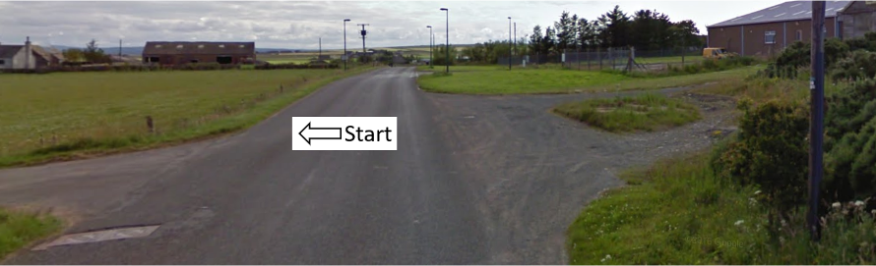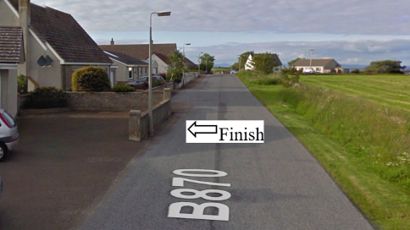

Traffic Flows: The course is a Circuit

Course/Event History: This course has been used regularly for over 5 years.

The first 5.59 miles is on normal roads then the rest of the course is on Single Track Road.

Key Identified Risks

Distance | Location | Identified Significant Risk/Hazards | Level of Risk  Low/Med/High | Measures to reduce Risk  (if applicable)
Miles 0.0 | Start  Located at the road junction opposite the Recycling Centre 1 mile outside Thurso on the B874. | Traffic | Med | Signage to warn traffic.  Start coned off.  Timekeeper.  Marshall to push off competitors.  Marshalls to wear HiVis.
Miles 0.8 | Achscrabster turn off – go straight ahead | Minor road turnoff | Low | Minor road turn off – (No action required)
Miles 2.69 | Lieurary/Calder turn off – go straight ahead | Minor road turnoff | Low | Minor road turn off – (No action required)
Miles 5.59  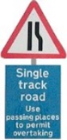 | Broubster/Shurrery junction - Turn Left onto single track road.  From here to the Finish the course is on Single Track road. | Turning left onto single track road | Low | Signage to warn traffic approaching the course.  Marshalls to warn traffic approaching the course.  Marshalls to wear HiVis.
Miles 9.49 | Dorrery junction – Turn Left. | Minor road turnoff.  Single Track road | Low | Signage to warn traffic approaching the course.  Marshalls to warn traffic approaching the course.  Marshalls to wear HiVis.
Miles 11.02  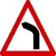 | Warning - Sharp Left-Hand bend. | Sharp Left Hand bend at the top of a short uphill climb. | Low | No action required
Miles 11.77 | Give Way and turn Left onto Halkirk road.  Single Track road | Minor Road Junction. Traffic on the road ahead has right of way. | Med | Cyclist to give way to traffic and observe the highway code.  Signage to warn traffic approaching the course.  Marshalls to warn traffic approaching the course.  Marshalls to wear HiVis.
Miles 13.24 | Glengolly junction – Turn Left onto B870.  Single Track road | Minor road junction.  Single Track road | Low | Signage to warn traffic approaching the course.  Marshalls to warn traffic approaching the course.  Marshalls to wear HiVis.
Miles 13.69 | Westfield turn off – go straight ahead | Minor road junction | Low | Minor road turn off – (No action required)
Miles 10.0 | Finish - at the lampost at the first house entering Glengolly. |  | Low | Time keeper  Recorder  Signage to warn traffic  Marshalls to wear HiVis

NOTES:

1. The use of a vehicle for the timekeeper(s) at start and finish is where appropriate and is only identified as an example for the action to be taken
2. The small junctions or entrances to farms/ facilities (garage,.eatery, etc) that are not identified in this risk assessment have been considered, however are not considered significant to pose a risk and therefore have not been noted.

Date of original Assessment: 23/08/2018

