 | Risk Assessment
Course/Road(s) Assessed: WN18/01 | Course: CCC 18m 2up TT
Date of Assessment/Review: 12/02/2019 | Name of Assessor: Committee

Course Description: Caithness Cycling Clubs 18-mile 2up Time Trial.

Start at the lamppost on the exit from the BT Business Park on the road from Thurso to Reay at the end of the 40 MPH speed limit and proceed on the A836 to Isauld (Reay) 8.98 miles.
Turn left and proceed 9.38 miles to the finish Opposite the lamppost across from the substation near North Highland College (18.3 miles).

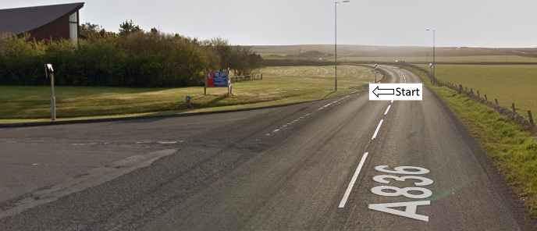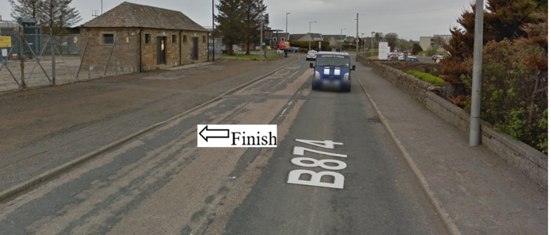

Traffic Flows: The course is a circuit

Course/Event History: This course has been used regularly for over 15 years.

Key Identified Risks

Distance | Location | Identified Significant Risk/Hazards | Level of Risk  Low/Med/High | Measures to reduce Risk  (if applicable)
Miles 0.0 | Start  At the lamppost on the exit from the BT Business Park on the road from Thurso to Reay (A836). | Traffic | Med | Signage to warn traffic.  Start coned off.  Timekeeper.  Marshall to push off competitors.  Marshalls to wear HiVis.
Miles 0.18 | Janetstown Crossroads | Minor Crossroads.  Go straight ahead | Low | Minor Croissroads(No action required)
Miles 4.0 | Crosskirk crossroads | Minor road crossroads.  Go straight ahead. | Low | Minor road crossroads (No action required)
Miles 6.54 | Achreamie turn off.  Go straight ahead. | Minor road turn off.  Go straight ahead | Low | Minor road turn off (No action required)
Miles 8.98 | Isauld turn off.  Turn Left. | Minor road junction.  Turn left | Low | Signage to warn traffic approaching the course.  Marshall to warn traffic approaching the course.  Marshalls to wear HiVis.
Miles 11.68 | Shebster turnoff,  Go straight ahead | Minor road turn off.  Go straight ahead | Low | Minor road turn off.  No action required.
Miles 15.14 | Lythmore turn off.  Go straight ahead. | Minor road turn off.  Go straight ahead | Low | Minor road turn off.  No action required.
Miles 16.86 | Janetstown turn off.  Go straight ahead. | Minor road turn off.  Go straight ahead | Low | Minor road turn off.  No action required.
Miles 18.19 | Thurso 30mph | No Hazard | N/A
Miles 18.32 | Turnoff onto Henderson Street - housing estate.  Go straight ahead. | Minor road turn off.  Go straight ahead | Low | Minor road turn off.  No action required.
Miles 18.36 | Finish  Opposite the lamppost across from substation near North Highland College |  | Low | Signage to warn traffic  Marshalls to wear HiVis

NOTES:

1. The use of a vehicle for the timekeeper(s) at start and finish is where appropriate and is only identified as an example for the action to be taken
2. The small junctions or entrances to farms/ facilities (garage,.eatery, etc) that are not identified in this risk assessment have been considered, however are not considered significant to pose a risk and therefore have not been noted.

Date of original Assessment: 23/08/2018

