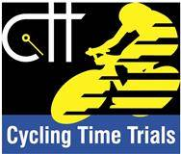 | Risk Assessment
Course/Road(s) Assessed: WN2/01 | Course: CCC 1.89m Hill Climb
Date of Assessment/Review: 12/02/2019 | Name of Assessor: Committee

Course Description: Caithness Cycling Clubs 2 mile Hill Climb.

Start at the lamppost at the exit from the BT Business Park on the road from Thurso to Reay. At the 40MPH sign.
Proceed for 1.89 miles to the finish at the entrance to the house at the top of the hill.

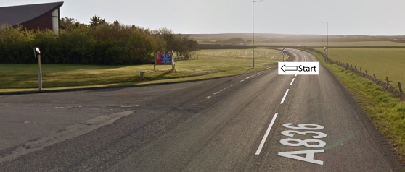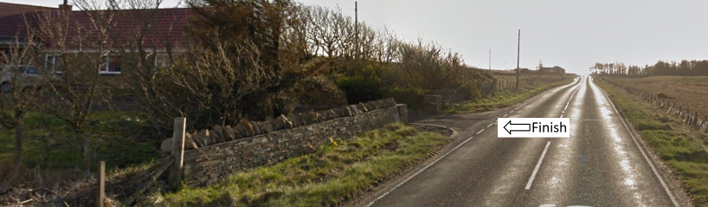

Traffic Flows: The course is an out only course.

Course/Event History: This course has been used regularly for over 15 years.

Key Identified Risks

Distance | Location | Identified Significant Risk/Hazards | Level of Risk  Low/Med/High | Measures to reduce Risk  (if applicable)
Miles 0.0 | Start  At the lamppost at the exit from the BT Business Park on the road from Thurso to Reay, at the 40MPH sign. | Traffic | Med | Signage to warn traffic.  Start coned off.  Timekeeper.  Marshall to push off competitors.  Marshalls to wear HiVis.
Miles 0.18 | Janetstown/Scrabster Crossroads | Minor road Crossroads.  Go straight ahead | Low | Minor road Crossroads. (No action required)
Miles 1.89 | Finish.  At the entrance to the house at the top of the hill. |  | Low | Signage to warn traffic  Marshalls to wear HiVis

NOTES:

1. The use of a vehicle for the timekeeper(s) at start and finish is where appropriate and is only identified as an example for the action to be taken
2. The small junctions or entrances to farms/ facilities (garage,.eatery, etc) that are not identified in this risk assessment have been considered, however are not considered significant to pose a risk and therefore have not been noted.

Date of original Assessment: 23/08/2018

