 | Risk Assessment
Course/Road(s) Assessed: CWN22/01 | Course: CCC 22mile Loch Calder Hilly TT
Date of Assessment/Review: 12/02/2019 | Name of Assessor: Committee

Course Description: Caithness Cycling Clubs 22mile Loch Calder Hilly TT course.

Start at lamppost opposite the Electrical Substation at North Highland College.
Proceed toward Reay, taking the second left (3.8m) onto the single track road at Bridge of Westfield.
Continue on to Achavarn (3.8m) (beware of the "Z" bend 1 mile after the junction) and turn left onto the B870 (single track road).
Proceed for 3.9m and turn left onto the B874 Halkirk to Thurso road.
Continue 0.3m and turn left onto the Thurso to Reay road, the start of the second lap, repeating the circuit a second time Finishing at the lampost at the first house entering Glengolly.

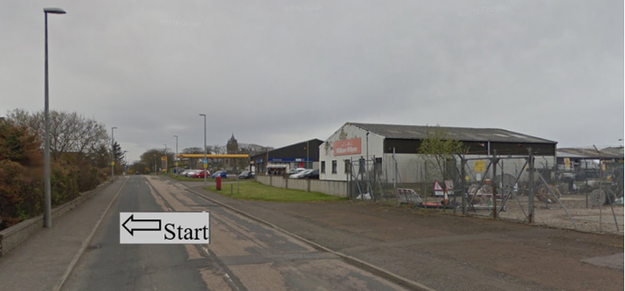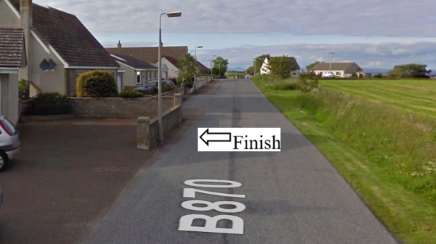

Traffic Flows: The course is a circuit and is 2 laps for the 11mile Hilly TT - WN11/01.

Course/Event History: This course has been used regularly for over 15 years. The circuit was changed to anti clockwise to reduce the risk of right hand turns.

Key Identified Risks

Distance | Location | Identified Significant Risk/Hazards | Level of Risk  Low/Med/High | Measures to reduce Risk  (if applicable)
Miles 0.0 | Start  Located at the lamppost opposite the substation near North Highland College. | Traffic | Med | Signage to warn traffic.  Start coned off.  Timekeeper.  Marshall to push off competitors.  Marshalls to wear HiVis.
Miles 0.2 | End of 30 mph speed limit |  | N/A | No action required
Miles 0.8 | Halkirk turn off.  Go straight ahead | Minor road turnoff | Low | Minor road turn off – (No action required)
Miles 3.8  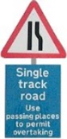 | Bridge of Westfield junction.  Turn Left onto single track road. | Turning left onto single track road | Low | Signage to warn traffic approaching the course.  Marshalls to warn traffic approaching the course.  Marshalls to wear HiVis.
Miles 4.3 | Z bend | Requires caution | Low | Cyclists to proceed through the Z Bend with caution noting that there might be on coming vehicles on the single track road.
Miles 7.4 | Give Way and turn Left onto B870 - Single track road | Minor Road Junction. Traffic on the road ahead have right of way. | Med | Cyclist to give way to traffic and observe the highway code.  Signage to warn traffic approaching the course.  Marshalls to warn traffic approaching the course.  Marshalls to wear HiVis.
Miles 11.3 | Give Way and turn Left onto B874 – Halkirk to Thurso | Minor Road Junction. Traffic on the road ahead have right of way. | Med | Cyclist to give way to traffic and observe the highway code.  Signage to warn traffic approaching the course.  Marshalls to warn traffic approaching the course.  Marshalls to wear HiVis.
Miles 11.6 | Give Way and turn Left onto the Thurso to Reay road (Lap 2) | Minor Road Junction. Traffic on the road ahead have right of way. | Med | Cyclist to give way to traffic and observe the highway code.  Signage to warn traffic approaching the course.  Marshalls to warn traffic approaching the course.  Marshalls to wear HiVis.
Miles 14.6 | Bridge of Westfield junction. Turn Left onto single track road | Turning left onto single track road | Low | Signage to warn traffic approaching the course.  Marshalls to warn traffic approaching the course.  Marshalls to wear HiVis.
Miles 15.1 | Z bend | Requires caution | Low | Cyclists to proceed through the Z Bend with caution noting that there might be on coming vehicles on the single track road.
Miles 18.8 | Give Way and turn Left onto B870 - Single track road | Minor Road Junction. Traffic on the road ahead have right of way. | Med | Cyclist to give way to traffic and observe the highway code.  Signage to warn traffic approaching the course.  Marshalls to warn traffic approaching the course.  Marshalls to wear HiVis.
Miles 21.88 | Finish - at the lampost at the first house entering Glengolly. |  | Low | Time keeper.  Recorder.  Signage to warn traffic.  Marshalls to wear HiVis.

NOTES:

1. The use of a vehicle for the timekeeper(s) at start and finish is where appropriate and is only identified as an example for the action to be taken
2. The small junctions or entrances to farms/ facilities (garage,.eatery, etc) that are not identified in this risk assessment have been considered, however are not considered significant to pose a risk and therefore have not been noted.

Date of original Assessment: 23/08/2018

