 | Risk Assessment
Course/Road(s) Assessed: WN25/01 | Course: CCC 25mtt NS7
Date of Assessment/Review: 12/02/2019 | Name of Assessor: Committee

Course Description: Caithness Cycling Clubs 25 mile TT course (BC - NS7).
The course is a registered British Cycling course (NS7).

Start on A9 50 yards east of "Welcome to Thurso" sign on south side of Thurso, continue on A9/A882 through Watten to turn 1 mile east of Watten village (12.5 miles). Retrace to finish 400 yards short of start (25 miles).

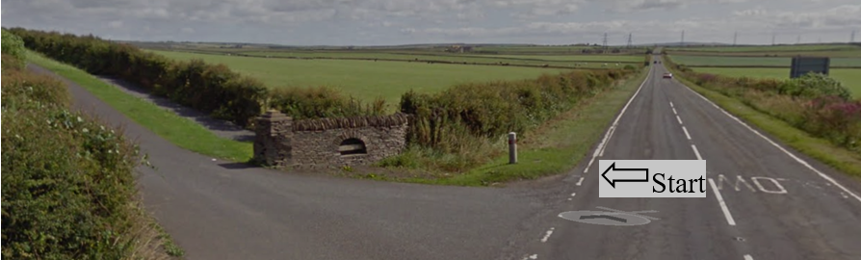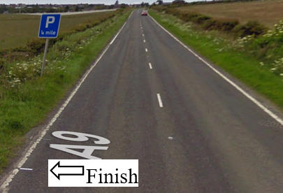

Traffic Flows: The course is an out and back course with a Dead Turn.

Course/Event History: This course has been used regularly for over 20 years.

Key Identified Risks

Distance | Location | Identified Significant Risk/Hazards | Level of Risk  Low/Med/High | Measures to reduce Risk  (if applicable)
Miles 0.0   | Start  Located at farm entrance road just outside Thurso on the A9. | Traffic | Med | Signage to warn traffic  Start coned off  Timekeeper  Marshall to push off competitors  Marshalls to wear HiVis
Miles 2.0   | Weydale turnoff – straight on | Minor road turn off | Low | Minor road turn off (No action required)
Miles 3.5 | Sordale turnoff - straight on | Minor road turn off | Low | Minor road turn off (No action required)
Miles 4.4   | Roadside turnoff - straight on | Minor road turn off | Low | Minor road turn off (No action required)
Miles 4.5   | Roadside crossroads - straight on | Minor road turn off | Low | Crossroads from Roadside to Halkirk (No action required)
Miles 8.3 | Gillock turnoff - straight on | Minor road turn off | Low | Minor road turn off (No action required)
Miles 11.1   | Watten 30mph | No Hazard | N/A | 30 MPH speed limit
Miles 11.3   | Pedestrian Crossing | Hazard to cyclist & pedestrians | Med | Cyclists to observe Highway Code and give way to pedestrians
Miles 11.4 | Watten Crossroads - straight on | Minor road turn off | Low | Minor Crossroads in town of Watten (No action required)
Miles 11.5   | Watten end of 30mph | No Hazard | N/A | End of 30 MPH speed limit
Miles 12.5  Dead Turn   | Dead Turn – go past and round turn marshall | Oncoming traffic | Med | Cyclist to give way to traffic and observe the highway code.  Signage to warn traffic approaching the course.  Marshall to warn traffic approaching the course.  Marshalls to wear HiVis.
Miles 13.5 | Watten 30mph | No Hazard | N/A
Miles 13.6 | Watten Crossroads - straight on | Minor road turn off | Low | Minor Crossroads (No action required)
Miles 13.7 | Pedestrian Crossing | Hazard to cyclist & pedestrians | Med | Cyclists to observe Highway Code and give way to pedestrians
Miles 13.9 | Watten end of 30mph | No Hazard | N/A
Miles 20 | Georgmas turnoff - straight on | A9 Junction – cyclist has the right of way | Low | Signage to warn traffic turning onto the course
Miles 20.5 | Roadside crossroad - straight on | Minor road turn off | Low | Crossroads from Roadside to Halkirk (No action required)
Miles 25   | Finish 400 yards short of the Start. |  | Low | Signage to warn traffic  Marshalls to wear HiVis

NOTES:

1. The use of a vehicle for the timekeeper(s) at start and finish is where appropriate and is only identified as an example for the action to be taken
2. The small junctions or entrances to farms/ facilities (garage,.eatery, etc) that are not identified in this risk assessment have been considered, however are not considered significant to pose a risk and therefore have not been noted.

Date of original Assessment: 23/08/2018

