 | Risk Assessment
Course/Road(s) Assessed: WN50/01 | Course: CCC 50mTT Lochshell
Date of Assessment/Review: 12/02/2019 | Name of Assessor: Committee

Course Description: Caithness Cycling Clubs CCC 50mTT – (Lochshell)

Start on A9 50 yards east of "Welcome to Thurso" sign on south side of Thurso, continue on A9/A882 and turn left at the crossroads in Watten at 11.46 miles. Continue across the Level Crossing to the junction and turn left at 12.73 miles. Continue for 0.5 miles and tun left at the junction at 13.21 miles then proceed for 5.3 miles to the Dead Turn at 18.51 miles.
Retrace and turn right at 23.81 miles then carry straight on for 7.42 miles to the Loch Shell junction (31.23 miles) (B876) and turn Left.
Continue for 14.09 miles to the junction with the A836 in Castletown (45.32 Miles) and turn left and continue for 4.68 miles to the Finish at railings before Pedestrian Crossing at Mount Pleasant School in Thurso (50 miles).
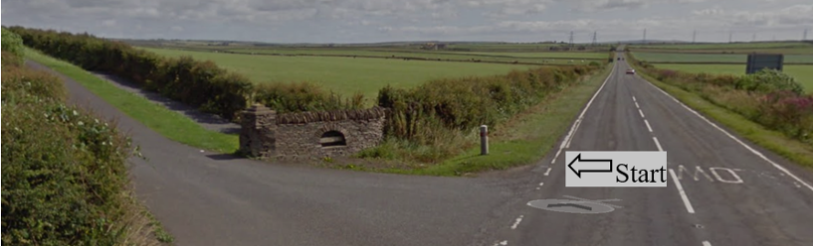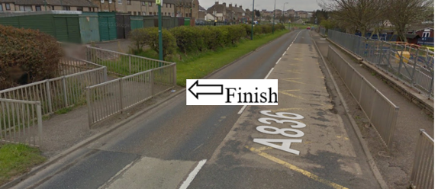

Traffic Flows: The course is a circuit with a Dead Turn.

Course/Event History: This course has been used regularly for over 5 years.
The middle section of the course is Single Track road.

Key Identified Risks

Distance | Location | Identified Significant Risk/Hazards | Level of Risk  Low/Med/High | Measures to reduce Risk  (if applicable)
Miles 0.0 | Start  Located at farm entrance road just outside Thurso on the A9. | Traffic | Med | Signage to warn traffic  Start coned off  Timekeeper  Marshall to push off competitors  Marshalls to wear HiVis
Miles 2.0 | Weydale turnoff – straight on | Minor road turn off | Low | Minor road turn off (No action required)
Miles 3.5 | Sordale turnoff - straight on | Minor road turn off | Low | Minor road turn off (No action required)
Miles 4.4 | Roadside turnoff - straight on | Minor road turn off | Low | Minor road turn off (No action required)
Miles 4.5 | Roadside crossroads - straight on | Minor road crossroads | Low | Crossroads from Roadside to Halkirk (No action required)
Miles 8.3 | Gillock turnoff - straight on | Minor road junction. | Low | Minor road turn off (No action required)
Miles 11.1  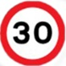 | Watten 30mph | No Hazard | N/A | 30 MPH speed limit
Miles 11.3  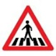 | Pedestrian Crossing | Hazard to cyclist & pedestrians | Med | Cyclists to observe Highway Code and give way to pedestrians
Miles 11.46 | Watten Crossroads – Turn Left onto the B870. | Minor road turn left | Low | Minor Crossroads in town of Watten (No action required)
Miles 11.74 | End of 30 mph speed limit |  | N/A | No action required
Miles12.49 | Level Crossing.  Stop if Lights Show, otherwise straight ahead. | Cyclist at risk if they do not Stop when the Lights Show. | Low | Cyclists to observe Highway Code and Stop when the Lights Show.
Miles 12.73 | Give Way and Turn Left at the junction onto the B874. | Minor Road Junction. Traffic on the road ahead have right of way. | Med | Cyclist to give way to traffic and observe the highway code.  Signage to warn traffic approaching the course.  Marshalls to warn traffic approaching the course.  Marshalls to wear HiVis.
Miles 12.99 | Sharp Right hand bend. | Restricted visibility. | Low | Signage to warn traffic approaching the course.  Marshalls to warn traffic approaching the course.  Marshalls to wear HiVis.
Miles 13.21 | Turn Left on the B874. | Traffic | Low | Signage to warn traffic approaching the course.  Marshalls to warn traffic approaching the course.  Marshalls to wear HiVis.
Miles 16.25 | Gillock 30mph | No Hazard | N/A | 30 MPH speed limit
Miles 16.42 | End of Gillock 30 mph speed limit |  | N/A | No action required
Miles 16.93 | Minor Road junction - straight on | Minor road junction. | Low | Minor road junction (No action required)
Miles 18.51  Dead Turn | Dead Turn at the entrance to Stemster Farm/House (B874) – go past and round turn marshall | Oncoming traffic | Med | Cyclist to give way to traffic and observe the highway code.  Signage to warn traffic approaching the course.  Marshall to warn traffic approaching the course.  Marshalls to wear HiVis.
Miles 19.34 | Minor Road junction - straight on. | Minor road junction. | Low | Minor road junction (No action required)
Miles 20.14 | Minor Road junction - straight on | Minor road junction. | Low | Minor road junction (No action required)
Miles 20.58 | Gillock 30mph | No Hazard | N/A | 30 MPH speed limit
Miles 20.69 | Minor Road junction - straight on | Minor road junction. | Low | Minor road junction (No action required)
Miles 20.77 | End of Gillock 30 mph speed limit |  | N/A | No action required
Miles 21.42 | Minor Road junction - straight on | Minor road junction. | Low | Minor road junction (No action required)
Miles 23.81 | Give Way and turn Right at the junction | Minor Road Junction. Traffic on the road ahead have right of way. | Med | Cyclist to give way to traffic and observe the highway code.  Signage to warn traffic approaching the course.  Marshalls to warn traffic approaching the course.  Marshalls to wear HiVis.
Miles 24.02 | Sharp Left hand bend. | Restricted visibility. | Low | Signage to warn traffic approaching the course.  Marshalls to warn traffic approaching the course.  Marshalls to wear HiVis.
Miles 24.43 | Minor Road junction - straight on | Minor road junction. | Low | Minor road junction (No action required)
Miles 29.44 | Minor Road junction - straight on | Minor road junction. | Low | Minor road junction (No action required)
Miles 31.23 | Give Way and Turn Left at the junction onto the B876 - Lochshell.  (End of Single Track road) | Minor Road Junction (B876) Lochshell.  Traffic on the road ahead (B8976) has the right of way. | Med | Cyclist to give way to traffic and observe the highway code.  Signage to warn traffic approaching the course.  Marshalls to warn traffic approaching the course.  Marshalls to wear HiVis.
Miles 33.1 | Minor Road junction - straight on | Minor road junction. | Low | Minor road junction (No action required)
Miles 38.01 | Minor Road junction - straight on | Minor road junction. | Low | Minor road junction (No action required)
Miles 40.43 | Bower 40mph | No Hazard | N/A | 40 MPH speed limit
Miles 40.95 | Bower crossroads - straight on | Minor road crossroads | Low | Crossroads from Roadside to Halkirk (No action required)
Miles 41.12 | End of Bower 40 mph speed limit |  | N/A | No action required
Miles 43.06 | Minor Road junction - straight on | Minor road junction. | Low | Minor road junction (No action required)
Miles 44.9 | Castletown 30mph | No Hazard | N/A | 30 MPH speed limit
Miles 44.9 | Minor Road junction - straight on | Minor road junction. | Low | Minor road junction (No action required)
Miles 44.9 | Murryfield Road, Minor Road junction - straight on | Minor road junction. | Low | Minor road junction (No action required)
Miles 45.32 | Give Way and Turn Left onto the A836. | Minor Road Junction. Traffic on the road ahead have right of way. | Med | Cyclist to give way to traffic and observe the highway code.  Signage to warn traffic approaching the course.  Marshalls to warn traffic approaching the course.  Marshalls to wear HiVis.
Miles 45.64 | Castletown crossroads - straight on | Minor road crossroads | Low | Minor road junction (No action required)
Miles 46.15 | End of Castletown 30 mph speed limit |  | N/A | No action required
Miles 46.63 | Minor Road junction - straight on | Minor road junction. | Low | Minor road junction (No action required)
Miles 47.14 | Minor Road junction - straight on | Minor road junction. | Low | Minor road junction (No action required)
Miles 48.08 | Murkle 50mph | No Hazard | N/A | 50 MPH speed limit
Miles 47.41 | Minor Road junction - straight on | Minor road junction. | Low | Minor road junction (No action required)
Miles 48.08 | End of Murkle 50 mph speed limit |  | N/A | No action required
Miles 49.71 | Thurso 30mph | No Hazard | N/A | 30 MPH speed limit
Miles 49.3  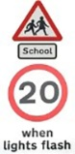 | 20MPH Speed Limit when Lights Flash | No risks identified as this course would normally be used on a Saturday or Sunday when the school is not open. | N/A | 20 MPH Speed Limit if lights are flashing
Miles 50 | Finish.  At railings of Attended School Crossing at Mount Pleasant School. |  | Low | Signage to warn traffic  Marshalls to wear HiVis
Miles 50  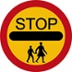 | Attended School Crossing (No Zebra Crossing markings) at Finish Line with 20MPH limit during School Entry and Exit times.  This course would normally be used on a Saturday or Sunday. | No risks identified as this course would normally be used on a Saturday or Sunday when the school is not open. | N/A | N/A

NOTES:

1. The use of a vehicle for the timekeeper(s) at start and finish is where appropriate and is only identified as an example for the action to be taken
2. The small junctions or entrances to farms/ facilities (garage,.eatery, etc) that are not identified in this risk assessment have been considered, however are not considered significant to pose a risk and therefore have not been noted.

Date of original Assessment: 23/08/2018

