 | Risk Assessment
Course/Road(s) Assessed: Wick/Thurso Interclub | Course: CCC/WW Interclub – Wick to Thurso
Date of Assessment/Review: 12/02/2019 | Name of Assessor: Committee

Course Description: Caithness Cycling Club / Wick Wheels (Wick to Thurso) Interclub Course.

Start in Wick on the A882 at the wall of the drive of the house just before Langley Ln.
Finish 4 yds before the “P ¼ Mile” sign ½ mile from Thurso 30mph sign.

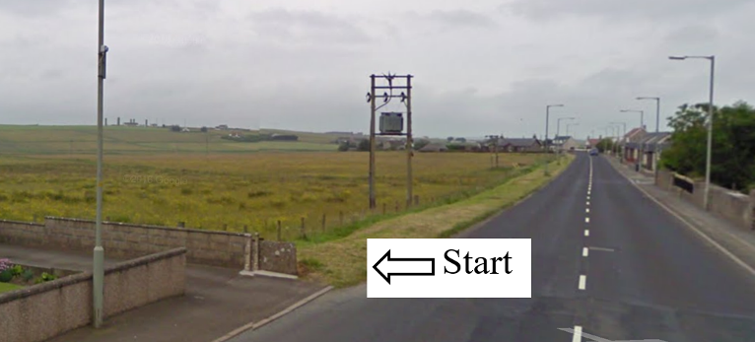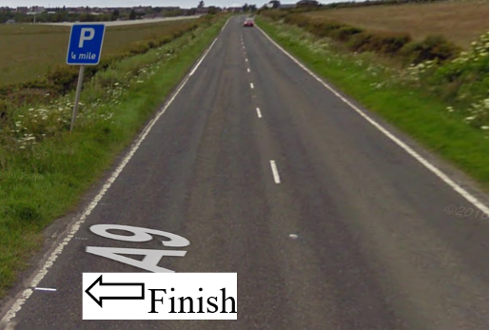

Traffic Flows: The course is from Wick to Thurso (one way)

Course/Event History: This course has been used regularly for over 15 years.

Key Identified Risks

Distance | Location | Identified Significant Risk/Hazards | Level of Risk  Low/Med/High | Measures to reduce Risk  (if applicable)
Miles 0.0 | Start  Start in Wick on the A882 at the wall of the drive of the house just before Langley Ln. (see picture above) | Traffic | Med | Signage to warn traffic  Start coned off  Timekeeper  Marshall to push off competitors  Marshalls to wear HiVis
Miles 1.95 | Haster turnoff – straight on | Minor road turn off | Low | Minor road turn off (No action required)
Miles 7.23 | Lybster turnoff - straight on | Minor road turn off | Low | Minor road turn off (No action required)
Miles 7.49  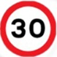 | Watten 30mph | No Hazard | N/A | 30 MPH speed limit
Miles 7.63 | Watten Crossroads - straight on | Minor road turn off | Low | Minor Crossroads in town of Watten (No action required)
Miles 7.72  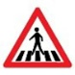 | Pedestrian Crossing | Hazard to cyclist & pedestrians | Med | Cyclists to observe Highway Code and give way to pedestrians
Miles 7.95 | Watten end of 30mph | No Hazard | N/A | End of 30 MPH speed limit
Miles 8.43 | Minor road turnoff - straight on | Minor road turn off | Low | Minor road turn off (No action required)
Miles 9.58 | Minor road turnoff - straight on | Minor road turn off | Low | Minor road turn off (No action required)
Miles 10.52 | Minor road turnoff - straight on | Minor road turn off | Low | Minor road turn off (No action required)
Miles 14.06 | Junction of A882 to A9 - straight on | Major road junction, joining traffic must give way. Cyclist has right of way. | Med | Major road junction, A9 joins A882 but does not have right of way.  Signage to warn traffic on A9 of Cycle Race in progress.
Miles 14.5 | Roadside crossroads - straight on | Minor crossroads | Med | Crossroads from Roadside to Halkirk (No action required)
Miles 18.974 | Finish 4 yds before the “P ¼ Mile” sign ½ mile from Thurso 30mph sign. |  | Low | Signage to warn traffic  Marshalls to wear HiVis

NOTES:

1. The use of a vehicle for the timekeeper(s) at start and finish is where appropriate and is only identified as an example for the action to be taken
2. The small junctions or entrances to farms/ facilities (garage,.eatery, etc) that are not identified in this risk assessment have been considered, however are not considered significant to pose a risk and therefore have not been noted.

Date of original Assessment: 09/02/2019

